**SSN College of Engineering**

**Department of Computer Science and Engineering**

**CSI and IEEE Student Chapter**

**Research Documentation using LaTeX Software - Workshop**

A one day workshop on Research Documentation using LaTeX Software, Feb 28,2019. The workshop on Research Documentation using LATEX software was organized by CSI student chapter, Department of Computer Science and Engineering , in association with CSI and IEEE Student chapter on 28th February,2019.

Faculty Coordinators : Dr.D.Venkata Vara Prasad, Dr.A.Chamundeswari and Mr.V. Balasubramanian

Student Organisers : Rakesh.M, Vivek.Y ,Tarun Ganesh.K ,Omprakash.R and Sandhiya Priya.S.

No of Participants : 36

Speakers : Dr.R.S.Milton, Dr.R.Kanchana, Dr. S.Sheerazudhin, Dr.J.Suresh and

Dr.K.Vallidevi

The first session was engaged by Dr. R.S. Milton, Professor, CSE, SSN. He covered the topic, Preparation using IPE . Dr. S. Sheerazuddin, Associate Professor, CSE, SSN, gave a introduction to Latex article. In the next session, formatting text, verbatim, and images topics was handled by Dr. K. Vallidevi, Associate Professor, CSE, SSN. In the afternoon, the first session was handled by Dr. J. Suresh, Associate Professor, CSE, SSN. He delivered a talk on mathematical equations. The last session was handled by Dr. R. Kanchana Associate Professor, CSE, SSN. She discussed on preparation of journal article / reports, abstracts, bibliographies, and graphs. Hands on training was given in all the sessions. Thanks to all speakers, volunteers and participants for completing the workshop successfully.

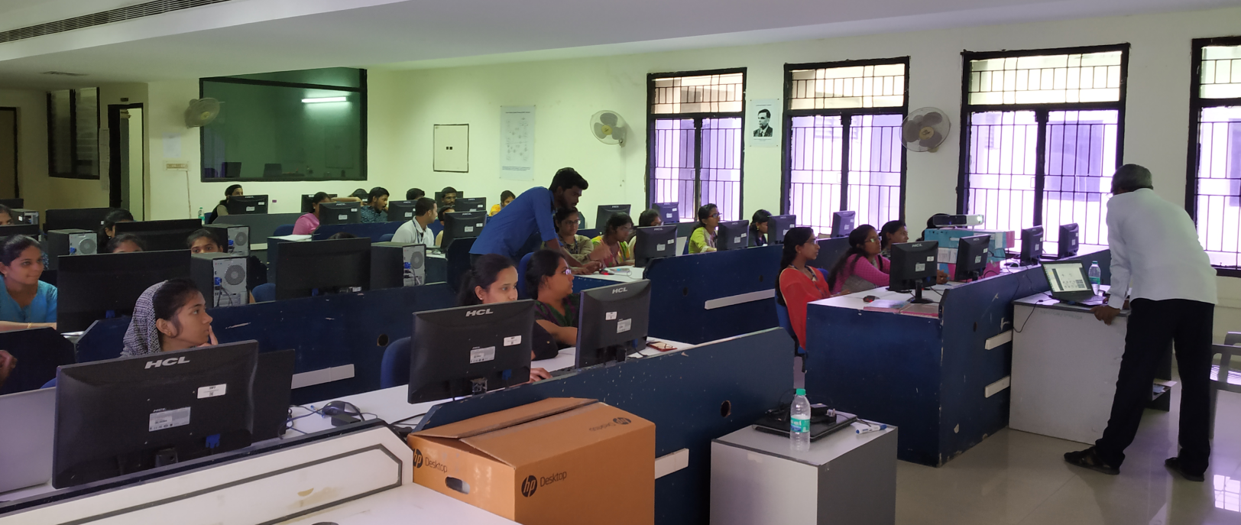

Rakesh M, Vivek.Y ,Tarun Ganesh.K ,Omprakash.R and Sandhiya Priya.S.